Stats for Fall 2019

Instructional Design Services (IDS)
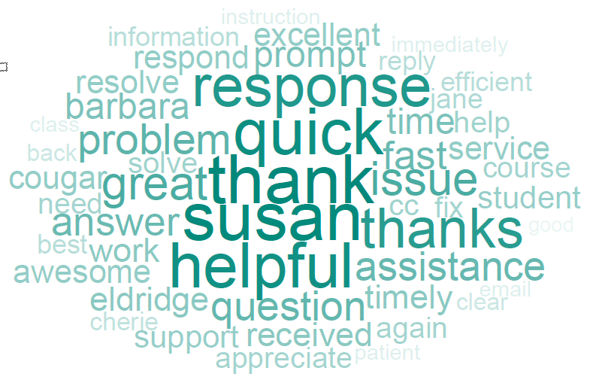
Wordle representing word frequency in customer survey comments.
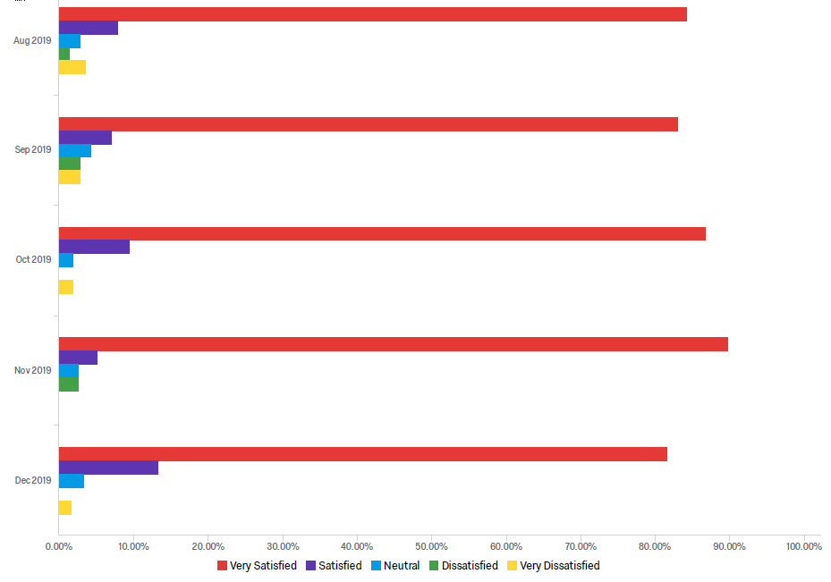
Customer satisfaction survey results for Fall semester 2019.

Reports of Dissatisfaction
- Customer error in completing survey (167165). Says “Quick response with the information I needed, thanks!” but accidentally checked Very Dissatisfied.
- Communications (164892). ID team member was posting to Private so instructor was not seeing timely communications.
- Customer error in completing survey (163722). Says “Very professional group!” but accidentally checked Very Dissatisfied.
- Communications - ID team member seems to have answered a different question than what was asked (160937).
- Communications (160537) – instructor says “Did not answer my original question.” It appears to me that she did answer the question tho.
- Communications (159428) – answer was sent promptly the next morning, but instructor says she did not get it. User error in my opinion.
- Communications (158921) – ID team member error – answering in Private instead of Public.
- Department org (158568) – coordinator did not provide access to a particular instructor and she’s mad at us instead of her own staff.
- Communications (158533) – ID team member error – answering in Private instead of Public.
- Communications (158291) – Special case “non-credit certificate program that is in the community container.” Student did not get email with instructions.
- Communications (157780) – [snip] doing the same thing – requesting help on Saturday night and being disappointed when it doesn’t show up until Monday morning.
- Version update (157526) – student doesn’t like the new version.
- Communications (156272) – ID team member error – answering in Private instead of Public.
- Communications (156148) – ID team member error – answering in Private instead of Public.
Obviously we have a problem with team members forgetting for set replies to Public so the client sees them.

- 1187 tickets for CC in Fall semester.
- 8.24 tickets/day - average for previous Fall semester was 10.9 t/d – representing a 12% decrease overall. So the update to the new version of Moodle was not as bad as it might have been.
- The loss of Susan Wilson will require a significant amount of work redistribution until she is replaced.

As can be seen over the past three semesters:
- Overall tickets are down –due to creation and maintenance of self-help tools. The overall deflection of several categories downward is the result of work and planning.
- Some targeted categories are down significantly:
  - Access – due to deliberate strategy of getting Help Desk to handle more up front, working with campus orgs to streamline identity processes.
  - Community – due to changes to processes and documentation spearheaded by Susan Eldridge.
  - Quiz, Gradebook, TurnItIn – better online help guides.
- Upward trend in Course Management issues is small but reflects more time spent addressing real instructional design questions, as well as the changes that occurred due to last year’s significant Moodle update.

GIS Stats
- 24 classes using GIS this semester
- 743 ARCGis accounts created
- 17 classes visited for training
CSUSM is in the top 20 of ArcGIS use in the nation.

Media Production Services (MPS)

Operations
The renovation of the Inspiration Studios was completed on-time. Functional spaces/services include:
- Studio A (2316) - virtual reality and general use
- Studio B (2311) - video production and general use
- Audio Studio and Learning Glass Studio (2324/2322)
- Recording and Editing Room A (2320)
- Recording and Editing Room B (2321)
- Photography Studio (2305)
- 3D Imaging and Production Studio (2306)
New spaces are highlighted in yellow.

Booked Hours
Spaces | Hours
Audio Studio/Learning Glass | 158
Recording and Editing A | 184
Recording and Editing B | 319
Studio A (VR) | 498
Studio B (video) | 179
Studio C (photo) | 143
 | 1678 hours

That averages out to about 17.29 hours of use per day across 20 weeks of Fall semester. This is significant usage and an increase overall.

Tickets
We have started integrating HelpSpot into more of our operations besides just trouble tickets from the HD. There were 494 tickets for Fall 2019:
- 357 studio reservation requests
- 57 caption requests
- 5 Mediasite problems
- 4 Photo requests

Mediasite Stats (Summer and Fall so far – thru 7 Oct)
Total Views: 148281
Views: 0 Live | 148281 On-Demand
Watched: 5818 of 25470 Presentations
Time: 29776:18:41 Total Watched (h:mm:ss)
Peak: 81 Connections
Clients: 8703 Users | 23068 IP Addresses | 15 Referrers

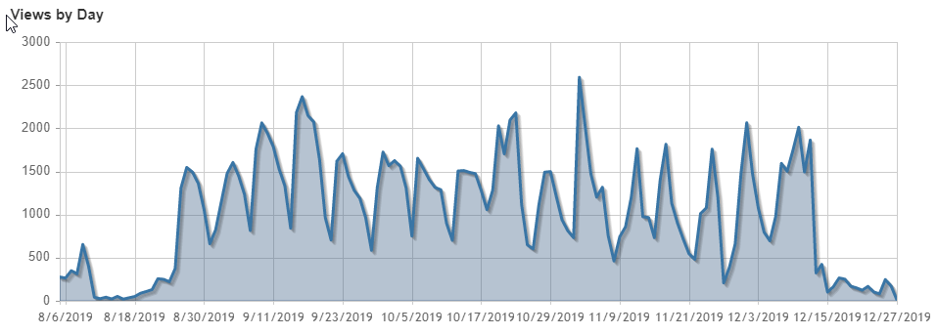

Authoring (Fall Semester)
- 1032 presentations created for 472 hours of content, or an average of 25 mins/video. This is a good reduction of time per recording, which hopefully indicates that our gospel of keeping things short is working.
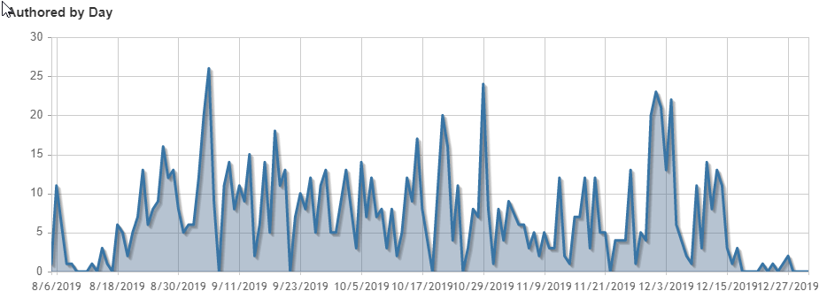

Zoom Stats (Fall Semester)
- Participants: 25,077
- Active Users: 585
- Meetings: 4,306
- Meeting Mins: 1,186,993
- Recording Storage Used: 1.43TB
- Webinars: 50
Zoom continues to be a stable and cost-effective communications tool.

Trendline indicates slow but steady increase in use.

Top Users
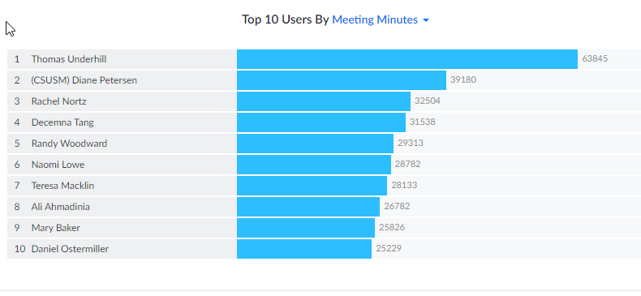
Note that “meeting minutes” are the cumulative total of all participants in a person’s meetings. So if you had ten people in your meeting for an hour, it would show up as 600 mins.
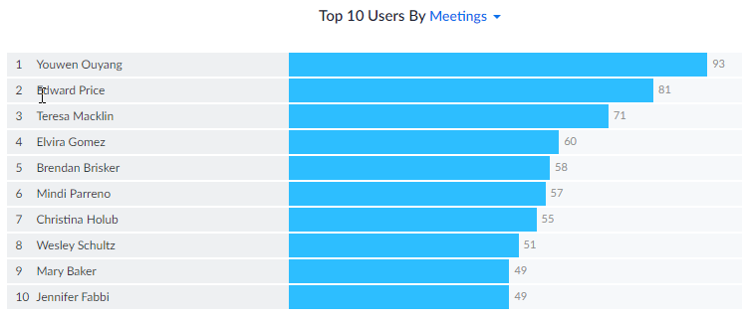

GIS Activity Report – Fall 2019
The Fall 2019 semester was the busiest semester yet for GIS support by IITS. Here are some summary statistics to describe GIS support provided by IITS:
- Number of course sections requesting GIS accounts: 24
- Number of course sections using GIS for the first time: 11
- Number of course sections requesting and receiving GIS presentations or in-class instruction/help from IITS: 16
- Number of students enrolled in those courses: 860
- Number of CSUSM account holders logging in to ArcGIS Online: 970
- Number of new ArcGIS Online accounts created during Fall 2019 semester: 735
- 589 AGOL users created 9,556 items on AGOL (maps, web apps, data layers, reports)
- 1,433 of these items were shared publicly, 2,729 items were shared within class or private groups

ArcGIS Online Usage over Time
Figure 1 reports statistics over time for the number of users of ArcGIS Online. “New Users” are the number of new ArcGIS Online accounts created over the course of the semester. The number of new user accounts created over the past four semesters has increased steadily. The higher rate of new accounts created during Spring and Fall of 2017 can be attributed partly to the presence of adjunct faculty in Liberal Studies (Geography) who were avid GIS users who have left CSUSM and partly to faculty who were GIS users moving into administrator positions, therefore teaching less. “Contributors” refers to ArcGIS account holders who create content (e.g., maps, web apps, data layers). Contributors can be either new account holders or users who have an account created in a previous semester. The number of Contributors closely follows the number of New Users.

Figure 2 reports the number of class sections for which new accounts and class groups were created. The number of class sections requesting ArcGIS Online accounts and class groups follows the same trend line as that of New Users and Contributors.
Figure 3 reports the number of items created by ArcGIS Online users. An important trend to note is the substantial overall increase in the number of items created by our ArcGIS Online users. This increase is most likely tied to a shift in the types of projects and assignments being assigned to students. Over time, the number of story map assignments and map assignments that include creation of analysis data layers have been increasing as our faculty become more comfortable and knowledgeable about using GIS in their courses. This trend is bound to continue and likely increase.

Captioning Services

Total minutes captioned in 2019: 18,311 (down from 20,191 calendar year or about 9%.

